Owen Public Library
Newsletter
May-June 2022

Owen Public Library Presents
Late Night at the Library
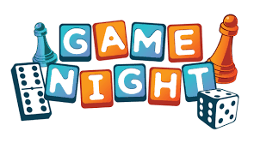
For teens and adults
May 20, 7-9:00 pm

Chat with other gamers, Eat snacks, Play Board Games, Help plan future game nights

RSVP not necessary but appreciated by May 16. You can RSVP by leaving us a message on FB, calling at 715-229-2939, e-mailing owen.wvls@gmail.com, Or just stopping by the library and letting us know.

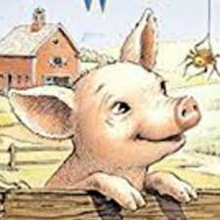
Charlotte and Wilbur’s Summer Library Program
Who: Kids ages 12 and under can participate.
Where: At the library and the Owen Farmer’s Market.
When: Sign-up begins on June 11. Stop by the library during open hours, Monday through Friday, 12-6:00 pm, or visit us at the Owen Farmer’s Market on June 11 & 18, July 2, 9 & 16. Complete the reading challenge and be awarded ride tickets for the Owen Jr. Fair.
How: Kids will get a reading log when they sign up for the program. Read 15 minutes a day for at least 6 days a week. Record your reading time in the log and have a parent verify the time read. Bring the log with you to the library so the librarians can check off your progress.
Join us for the program finale, Wilbur’s Pig-nic at 5:00 on July 22 at Mill Pond Park. We’ll have snacks and will hand out ride tickets to those who have finished the reading program.

Summer Beach Reads and Blockbusters
Who: teens and adults
What: A summer library program that’s not for kids! Check out books and DVDs, write a short review, and be entered into our prize drawing for a Barnes and Noble gift card. You can have up to 5 DVD entries and 5 book entries.
When: You can sign up beginning June 11.
How: When you sign up you will be given a brief review form. When you return a completed form, a librarian will enter your name into the drawing. Your review may be shared in the library or through social media. You must review items that you have checked out from the Owen Public Library. You can submit reviews until July 22. The drawing will be held Monday, July 25.

New At the Library
Adult Books
A Family Affair by R. Carr A Relative Murder by J. Devereaux Candy House by J. Egan
Summer by the Sea by S. Wiggs Citizen K-9 by D. Rosenfelt Investigator by J. Sanford
When she Dreams by A. Quick A Forgery of Roses by J. S. Olson Loving Edie by M. May
Forever Prisoner by C Scott-Clark Souls of Lost Lake by J. J. Wright Diamond Lily by H. Daulton
What Happened to the Bennetts by L. Scottaline Dream Town by D. Baldacci
The Tempting of Thomas Carrick by S. Laurens The Sacred Bridge by A. Hillerman

Young Adult Books
September Girls by B. Madison Say What You Will by C. McGovern Looking Glass by A. McNally
The Book of M by P. Shepherd Damsel by E. K. Arnold Cloudwish by F Wood
I Am the Ghost in Your House by M. Ramascoe-Moore Rough Magic by Prior-Palmer

Middle Grade Books
Long Lost by J. West Secret Starling by J. Eagle Disney Aristokittens #1 & #2
Albert Hopper, Science Hero by J. Himmelman The Body Under the Piano by M. Jocelyn
Jasmine Greene Rescues Books 3-6 by H. Peters The Not-So-Uniform Life of Holly-Mei by C. Matula

Easy Readers and Picture Books
Jack Gets Zapped by M. Barnett Bad Seed Goes to the Library by J. John Perfectly Pegasus by J. Sima
Bad Apple by H. Lewis Apple Grumble by H. Lewis The Library Fish by J. John
Pinkalicious: Message in a Bottle by V. Kahn

Adult DVDs
National Champion$ Red Rocket Legend of La Llorona Advice to Love By
House of Gucci The 355 Nightmare Alley West Side Story
Alaskan Dinosaurs Highway to Heaven Journal for Jordan The Tale
You Had Me at Aloha Scream For the Love of Money Benjamin Franklin

Children’s DVDs
Adventure Time: Distant Lands Magic School Bus Rides Again: S. 2
Arthur: Believe in Yourself 44 Cats: Season One
Spirit: The Untamed Clifford the Big Red Dog: The Movie

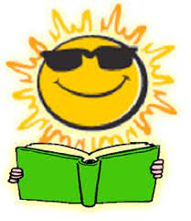
Summer Calendar
June
- 11 - Summer program kicks off at the Farmer’s Market
- 18 - Farmer’s Market
- 24 Late Night at the Library - Adult Coloring

July
- 2 - Farmer’s Market
- 4 - Library closed
- 9 - Farmer’s Market
- 16 - Farmer’s Market
- 22 - Summer reading wraps up; Owen Jr. Fair begins
- 25 - Adult summer reading prize drawing
- 29 - Late Night at the Library - Adult Game Night

